AP US Government
Seim
Respond to all parts of the question. In your response, use substantive examples where appropriate.

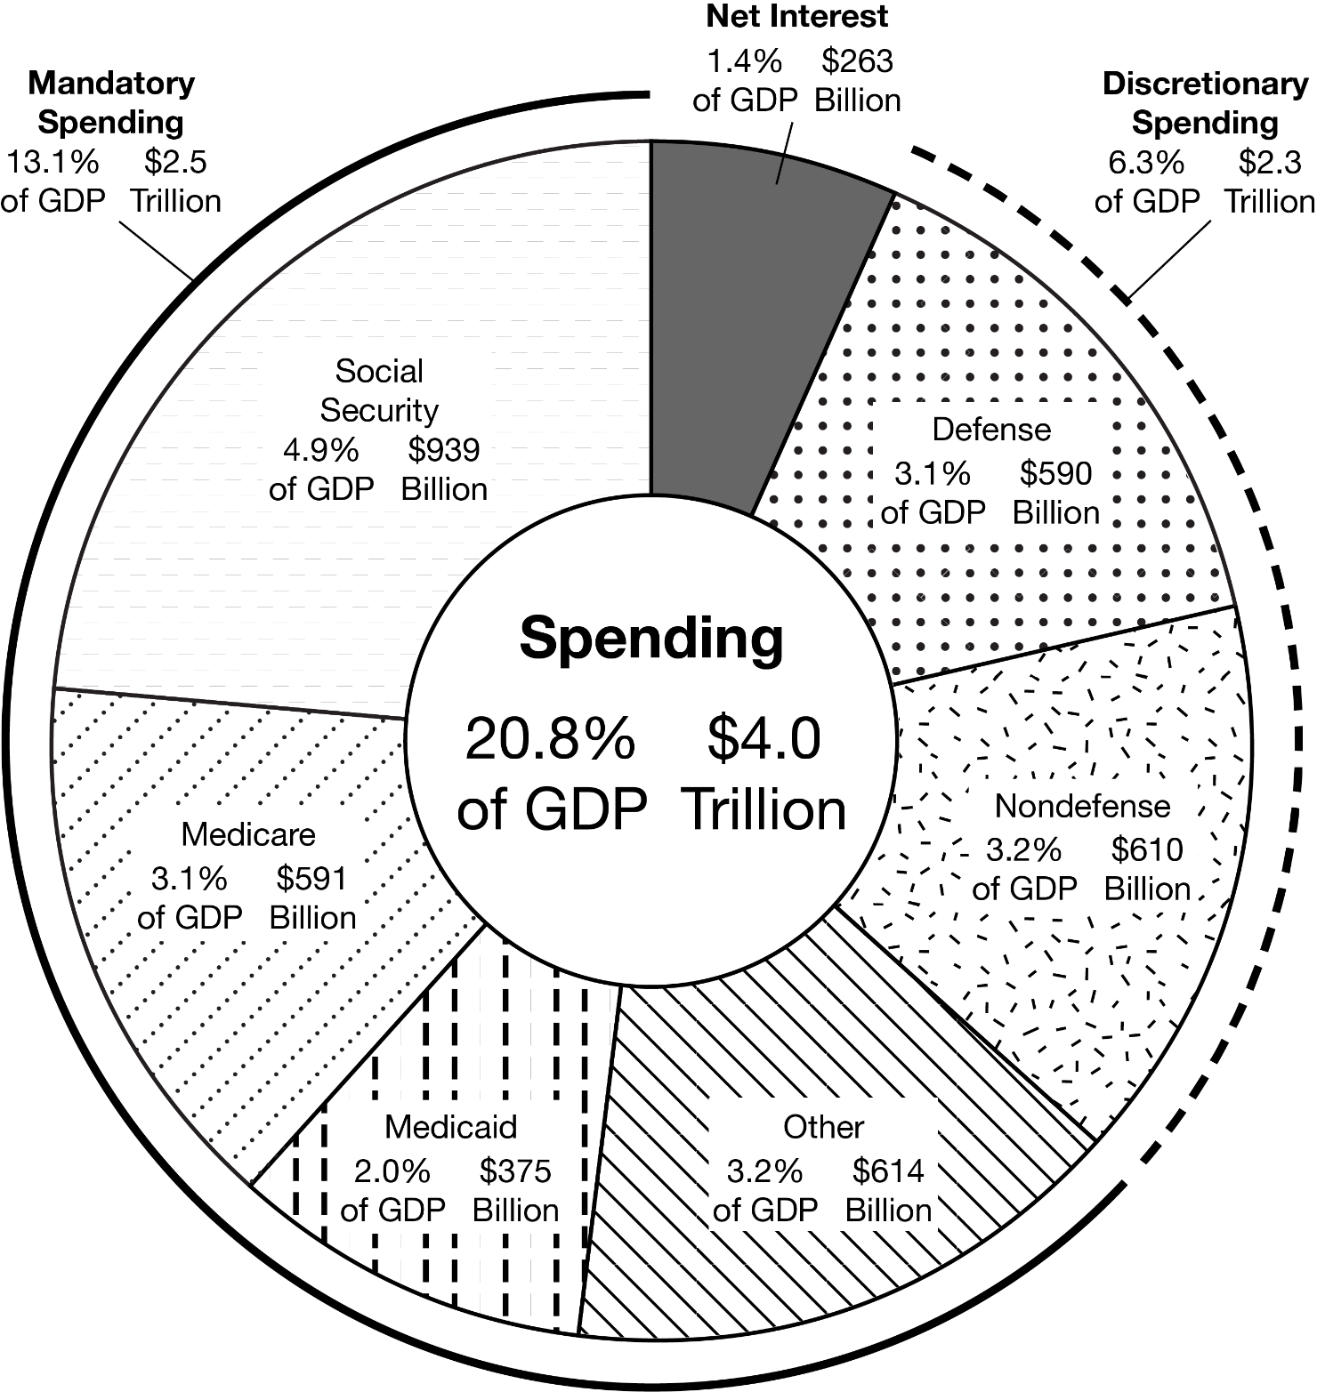
Source: Leigh Angres and Jorge Salazar, “The Federal Budget in 2017,” Congressional Budget Office, March 2018.
Use the chart to answer the following questions.
- Identify the category with the largest amount of mandatory spending, according to the chart.
- Describe the difference in spending between the mandatory and discretionary categories, according to the chart.

